Task 3 & 4 — SQL Data Setup and Analysis
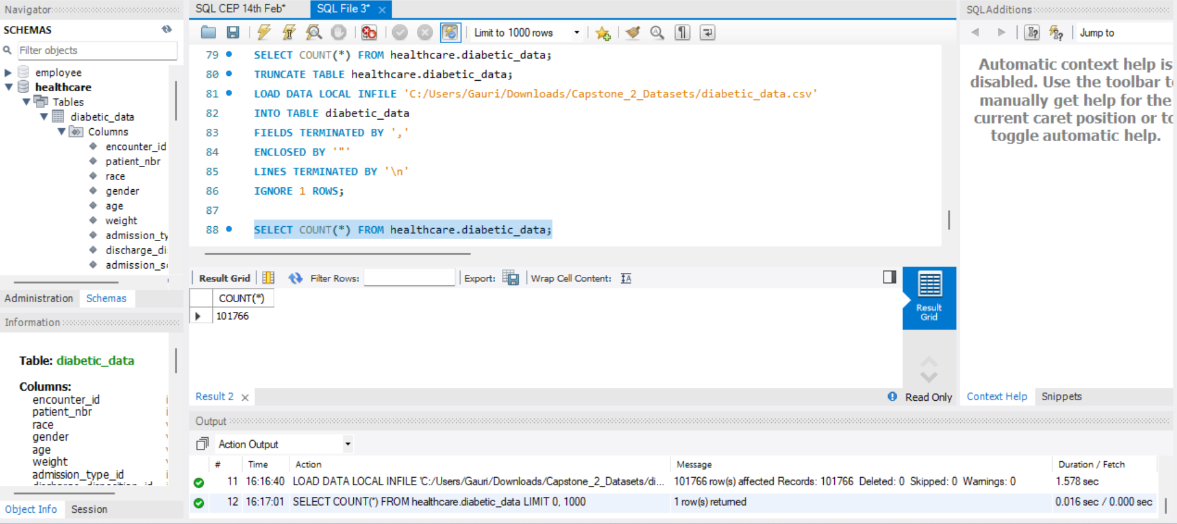

Query 1 — Total Patient Encounters

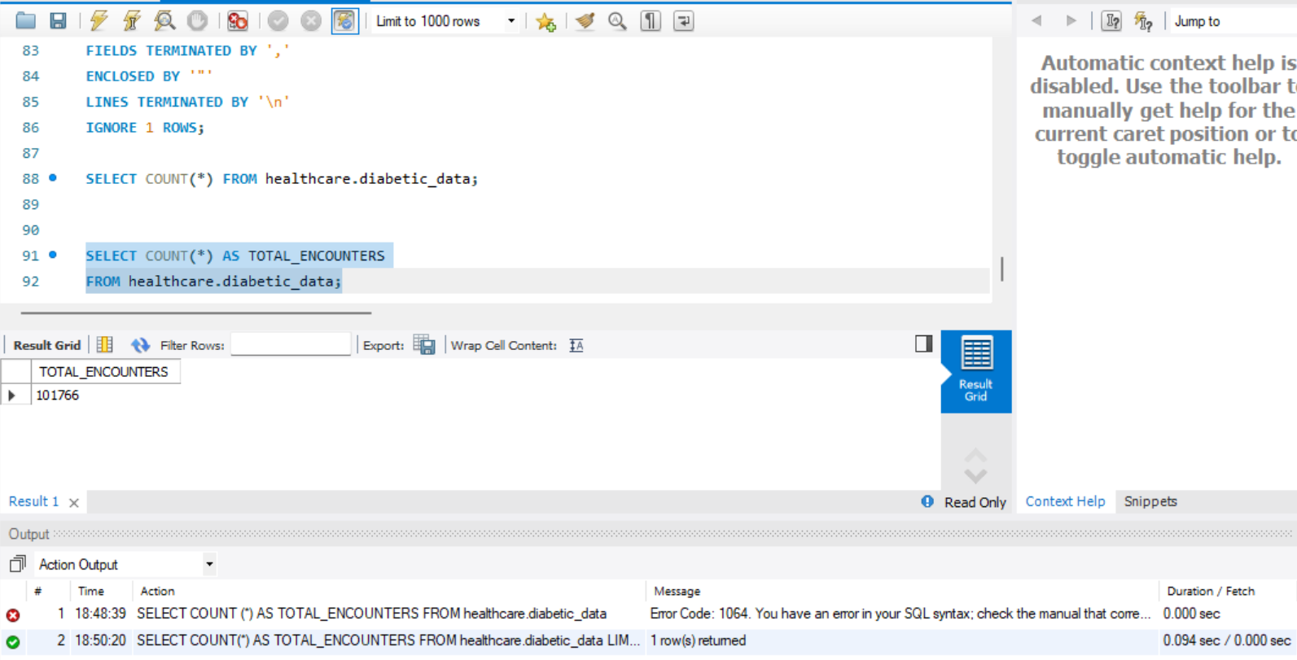
Business Insight: ReadmitGuard Analytics is working with over 100,000 patient records — this is a large, statistically reliable dataset. Any insights and recommendations drawn from this analysis are credible enough to support hospital policy decisions, budget planning, and clinical program design. This is not a small sample — this is real-world scale data

Query 2 — Top 10 Most Frequent Diagnoses

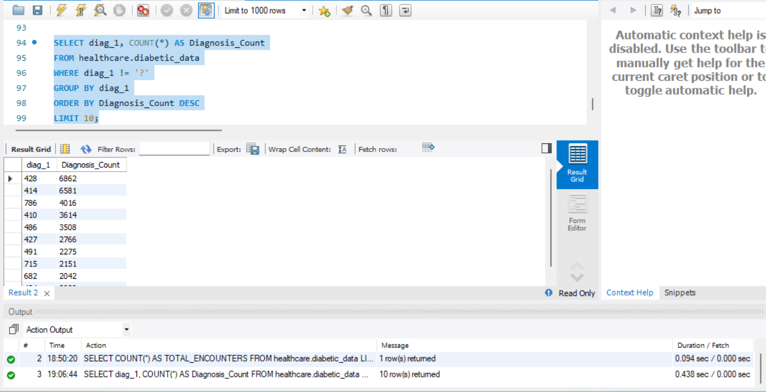

Business Insight: These are ICD-9 diagnosis codes. The top ones translate to:
- 428 = Heart Failure
- 414 = Chronic Coronary Artery Disease
- 786 = Respiratory Symptoms
- 410 = Heart Attack
- 486 = Pneumonia
This is a critical finding — diabetic patients are predominantly being admitted for heart and respiratory conditions, not just diabetes itself. This tells healthcare managers that diabetic patients carry serious comorbidities. Clinical intervention programs must address cardiovascular health alongside diabetes management. Cardiology and pulmonology departments need to be deeply involved in diabetic patient care protocols.

Query 3- Average length of hospital stay for each admission type

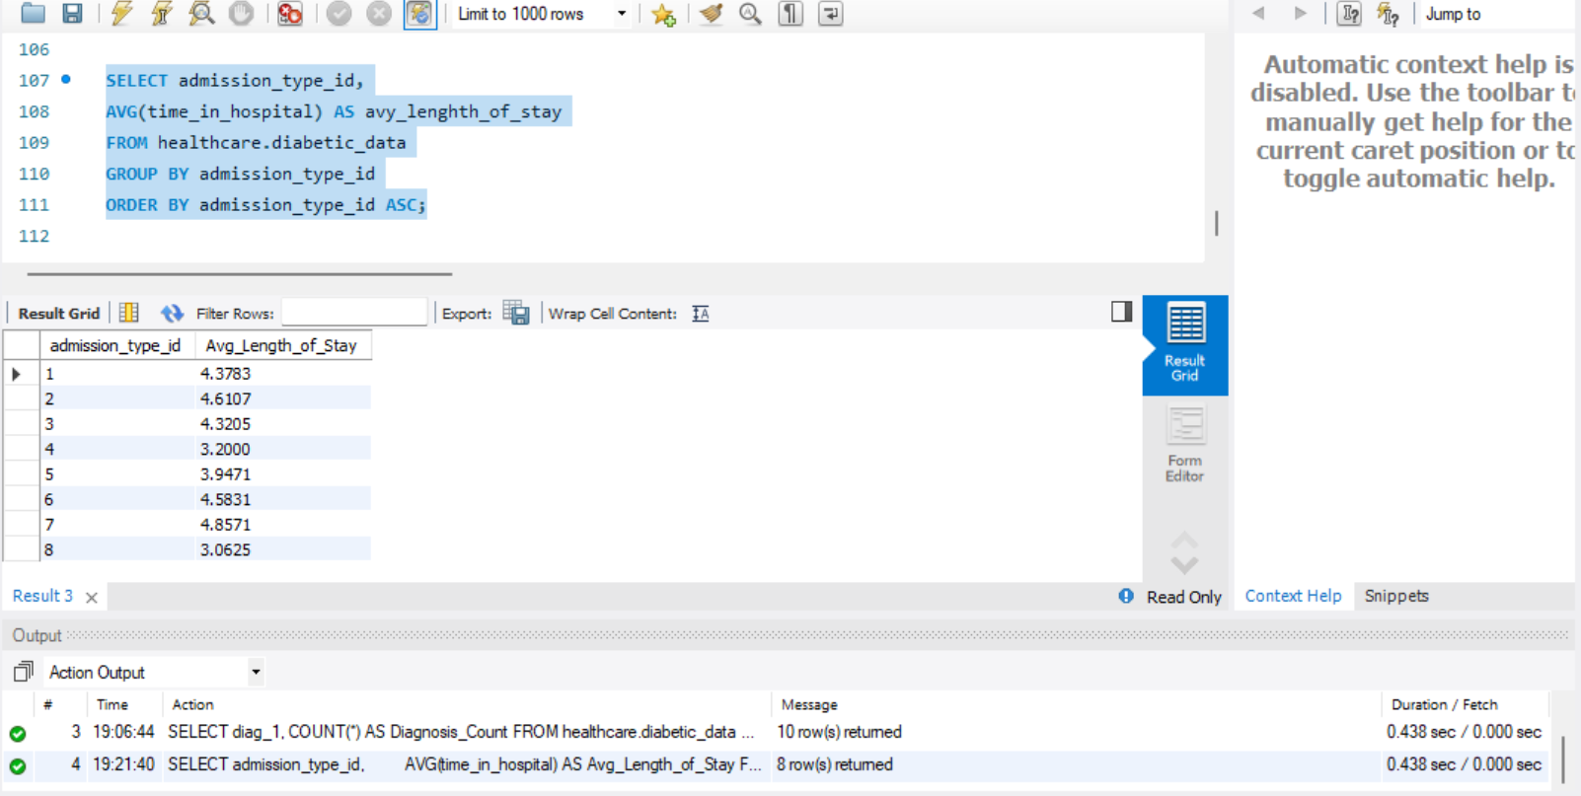

Business Insight: Admission Type 7 has the longest average stay at 4.86 days while Type 8 is the shortest at 3.06 days. The average across all types hovers around 4-5 days — this is your hospital capacity planning benchmark. Every bed occupied for 4-5 days by a diabetic patient is a resource allocation decision. If readmissions can be reduced by 11%, that frees up significant bed capacity for other patients. This data directly feeds into staffing rosters, bed management, and operational cost planning.

Query 4 -Number of readmitted patients and percentage of total encounters

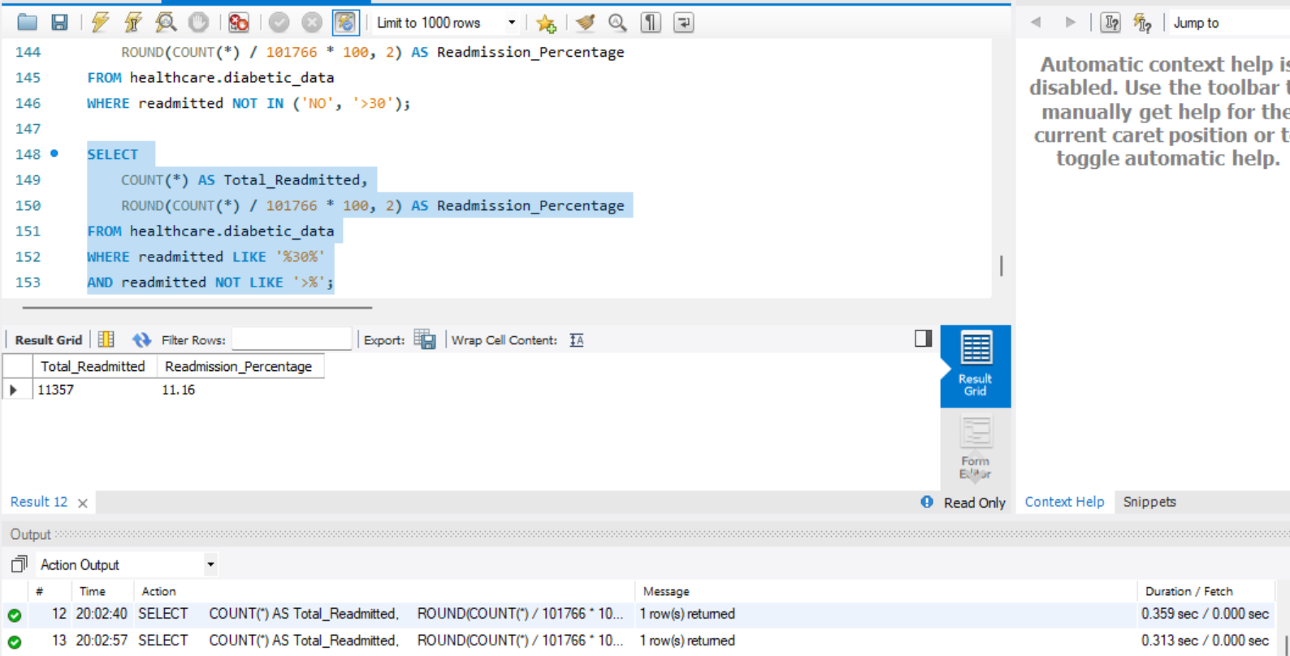

project. Here's what 11.16% means in real business terms:
- 1 in 9 patients is coming back within 30 days — that's a systemic problem, not an isolated incident
- At an estimated cost of $15,000-$20,000 per readmission, 11,357 readmissions = approximately $170M-$227M in additional healthcare costs
- This number is also a regulatory risk — hospitals with high 30-day readmission rates face financial penalties under healthcare quality programs
- Reducing this by just 3% through proactive intervention would prevent ~3,000 readmissions and save an estimated $45M-$60M annually
- This single insight justifies the entire investment in this analytics project
- Readmission Rate: 11,357 patients = 11.16%

Query 5 – Age distribution of patients

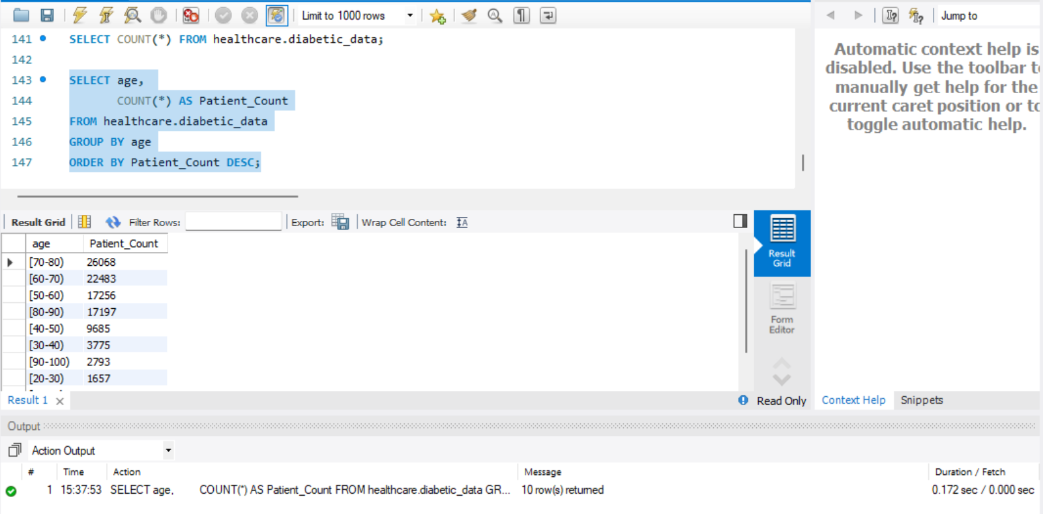

Business Insight: This is one of the most telling findings in the dataset. Over 65,000 patients — nearly 65% of all encounters — are aged 60 and above. This means:
- This is predominantly an elderly patient population — geriatric care protocols must be the priority
- Elderly patients have slower recovery rates, more comorbidities, and higher readmission risk — which directly explains that 11.16% readmission rate
- Post-discharge support is critical for this age group — they need follow-up call programs, home care visits, and medication management support after discharge
- The presence of 1,657 patients aged 20-30 is a warning signal — early onset diabetes is growing and requires a separate preventive care strategy
- Resource planning must skew heavily toward geriatric specialists, elderly-friendly facilities, and long-term care coordination

QUERY 6 — Most common procedures performed during patient encounters

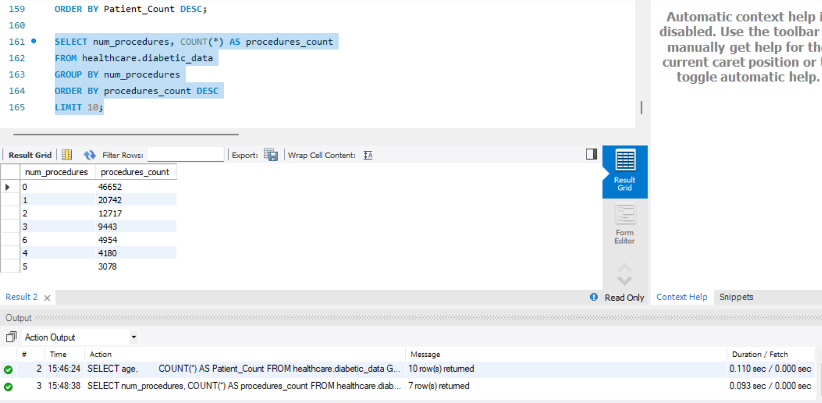

Business insight: Almost half of diabetic patients required no procedures during their stay — meaning their admissions were primarily for medication management and monitoring, not surgical intervention. This helps hospitals plan resource allocation accordingly.
Also I notice it only returned 7 rows not 10 — that's because there are only 7 distinct procedure count values in the data.

‘

QUERY 7 — Average number of medications prescribed for each age group.

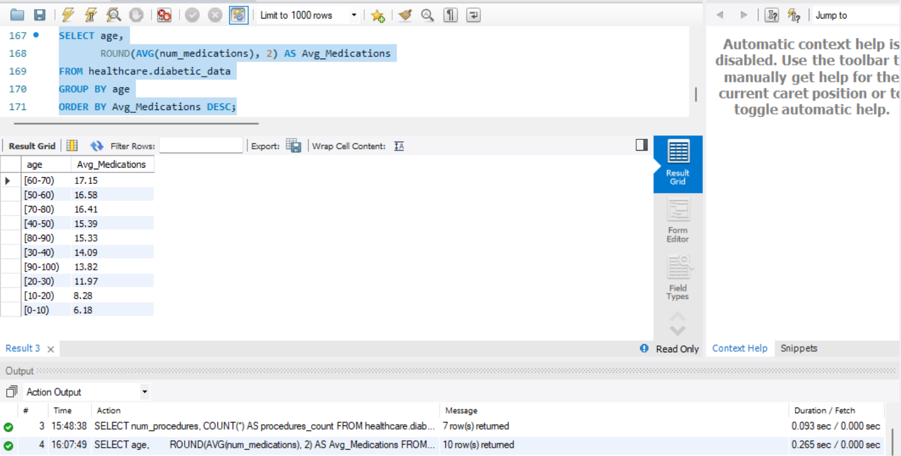

Quick business insight from your actual numbers: The 60-70 age group has the highest average at 17.15 medications per patient — nearly 3x more than the youngest patients. More medications = more complex cases = higher readmission risk. This directly connects back to our Query 5 finding where 60-70 was also the largest patient group. Double risk!

QUERY 8 — Distribution of readmission rates across different payer codes

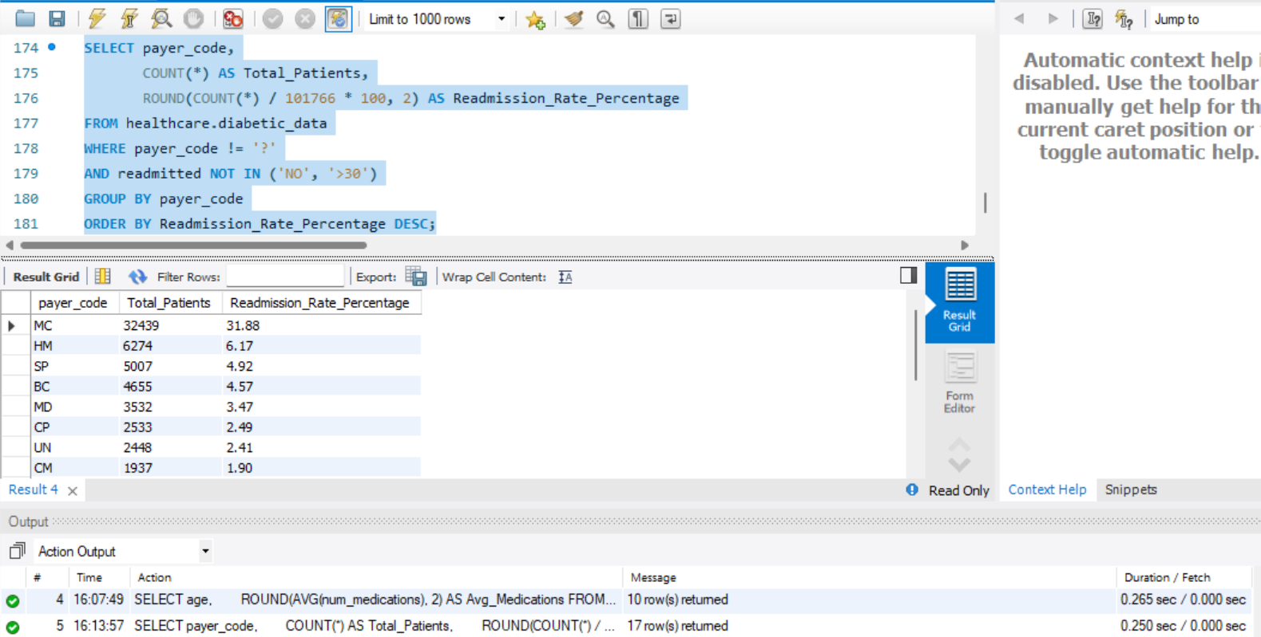

Quick business insight: MC (Medicare) dominates with 32,439 patients and 31.88% readmission rate — by far the largest and highest risk payer group. This makes sense because Medicare covers elderly patients (65+) which aligns perfectly with our Query 5 finding that 65% of patients are aged 60 and above. Medicare patients are sicker, older, and more likely to be readmitted.

